**Multiphysics Electric-thermal-fluid Simulation of PT Micro-heater Chip Subjected to Constant/Pulsed Current**

Claude Nzoundja Fapi[1],1, Xiaofeng Guo1, Laurent Royon2

1*LIED Laboratory, Université Paris Cité, Paris France*

2 *IUT de Paris Pajol, Université Paris Cité, Paris France*

**Abstract:**

*Enter an abstract of up to 250 words for all articles. This is a concise summary of the whole paper, not just the conclusions, and is understandable without reference to the rest of the paper. It should contain no citation to other published work. Include up to six keywords that describe your paper for indexing purposes. Supercritical water has received widespread attention due to its special physical and chemical properties. In some reactors related to supercritical water technology, such as supercritical water gasification, natural convection is a factor needing to be considered because of the high thermal compressibility of supercritical water. In this paper, numerical method is applied to analyze the natural convection and heat transfer characteristics of supercritical water in a side-wall heated cylinder. In order to match the actual situation, an inlet and an outlet are added to the bottom and the top of the cylinder respectively. After that, the quasi-DNS method is used for numerical simulation, and the thermodynamic properties of supercritical water are calculated by IAPWS-IF97 formulations. As a result, the flow structures and temperature inside the cylinder are analyzed. The characteristics and influence of the flow boundary layer are specially studied. Finally, a heat transfer correlation of supercritical water natural convection is proposed, and ways of heat transfer enhancement are discussed.*

***Keywords—****Supercritical water*, *Natural convection*, *Heat transfer.*

**1. Introduction**

Microelectromechanical systems (MEMS) technologies have been actively developed over the past two decades. Microscale heaters are key components of such technologies, which provide fast controlled heating of micro-volumes of medium to the required temperature level [1]. When the micro-heater is exposed to the liquid such as deionized water and FC-72, microscale boiling and transient bubble nucleation phenomena will be observed. Over the last decades, some researches have been performed to investigate the microscale boiling phenomena under either pulsed or constant heating conditions and the differences in the mechanisms between the conventional macroscale and microscale boiling and bubble nucleation [2].

PLEASE submit full papers within 6 pages.

Generally, many factors, such as the shape of the micro-heater and the heating conditions, are recognized to play a dominant role in the microscale boiling process. Leung et al. [3] observed two groups of boiling patterns generated by a set of different sizes of micro-heaters. Since the vapor in the bubble could be condensed outside the superheated region, the different boiling patterns and bubble dynamics was thought to be greatly dependent on the shape and size of the superheated region.

**2. Model and validation**

**2.1 Numerical model**

Figures are cited as "Fig 1" in sentences or as "Figure 1" at the beginning of sentence and paragraphs. Explanations related to figures should be given before figure. Figures and tables should be located at the top or bottom side of paper as done in accepted article format.

The sectional view of the physical model as shown in Fig. 1. In this figure, ...

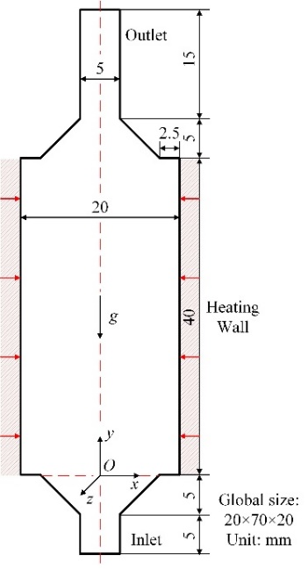

**Fig.1.** The sectional view of the physical model.

Authors are requested write equations using either any mathematical equation object inserted to word processor or using independent equation software. Symbols in your equation should be defined before the equation appears or immediately following. Use “Eq. (1)” or “equation (1),” while citing. Number equations consecutively with equation numbers in parentheses flush with the right margin, as in Eq. (1).

To make equations more compact, you may use the solidus (/), the exp function, or appropriate exponents. Italicize Roman symbols for quantities and variables, but not Greek symbols. Use a dash (-) rather than a hyphen for a minus sign. Use parentheses to avoid ambiguities in denominators.

The numerical simulation is carried out by OpenFOAM, which is an open-source computational fluid dynamics software. The continuity and momentum equations are written as follows:

 (1)

where *μ* is kinematic viscosity, *λ*' is the second viscosity coefficient, and Stokes hypothesis is used: *λ*'= -2/3*μ*.

Table captions should be written in the same format as figure captions; for example, “Table 1. Appearance styles”. Tables should be referenced in the text unabbreviated as “Table 1.”

In Table 1, the numerical simulation is carried out by OpenFOAM, which is an open-source computational fluid dynamics software.

**Table 1.** Boundary conditions of the domain.

|  |  |  |  |
| --- | --- | --- | --- |
|  | Velocity, *u* | Pressure, *p* | Temperature, *T* |
| Inlet |  |  |  |
| Outlet |  |  |  |
| Heating wall |  |  |  |
| Others |  |  |  |

**2.2 Mesh and model validation**

The numerical simulation is carried out by OpenFOAM, which is an open-source computational fluid dynamics software. The continuity and momentum equations are written as follows:

 (1)

where *μ* is kinematic viscosity, *λ*' is the second viscosity coefficient, and Stokes hypothesis is used: *λ*'= -2/3*μ*.

**Table 1.** Boundary conditions of the domain.

|  |  |  |  |
| --- | --- | --- | --- |
|  | Velocity, *u* | Pressure, *p* | Temperature, *T* |
| Inlet |  |  |  |
| Outlet |  |  |  |
| Heating wall |  |  |  |
| Others |  |  |  |

**3. Results and discussions**

**3.1 The flow structures and temperature profiles in the cylinder**

**3.2 Flow boundary layer characteristics**

**3.3 Wall heat transfer correlation and enhancement**

**4. Conclusions**

The conclusion section should emphasize the main contribution of the article to literature. Authors may also explain why the work is important, what are the novelties or possible applications and extensions. Do not replicate the abstract or sentences given in main text as the conclusion.

**Acknowledgment**

The authors may acknowledge to any person, institution or department that supported to any part of study.

**References**

1. K.M. Balaskó, L.H. Z. Kis, A. Aszódi. Experimental investigation of the thermal hydraulics of supercritical water under natural circulation in a closed loop. Annals of Nuclear energy. 100 178-203. 2017.
2. P.K. Leung, P. Deng, Y.K. Lee. Comparative Study of Size Effect of Micro Bubble Dynamics by Sub-100 Microsecond and Millisecond Pulse Heating. the 1st IEEE International Conference on Nano/Micro Engineered and Molecular Systems, 2006.
3. W.Q. Tao. Numerical Heat Transfer. Xi’an Jiaotong University Press. 2001.

1. *Corresponding author :* [*claude-bertin.nzoundja-fapi@u-paris.fr*](mailto:claude-bertin.nzoundja-fapi@u-paris.fr)